Thomke Mayer’s Illustration: An Artistic Critic on Urbanization
Name
Institution

Visual analysis
Artists have used artwork illustrations as an excellent way to encompass most of the human life aspects such as clothes, buildings, music, and our surrounding environments. As an old form of communication for human beings, artwork represents how humans have communicated and describes the human lives from the oldest history. It has remained and still remains an integral part of humanity. Thomke Mayer’s Artwork shown below is one of the artworks that can be used to illustrate some important aspects of human life. This illustration depicts a homestead located in a city with a man admiring the golden sky of a sun set on a playground slide on the compound. The illustration is made up of drawings and paintings that vividly bring out various elements of composition. This illustration symbolically shows a connection between humanity and the environment and depicts nature as a source of human comfort and peace. At the same time, it shows the struggle that human beings have to access natural environment as well as the gifts of nature like sunlight, breezes and sky beauty in an urban setting. It presents a struggle of a city dweller to have maximum enjoyment of the nature at the comfort of their home
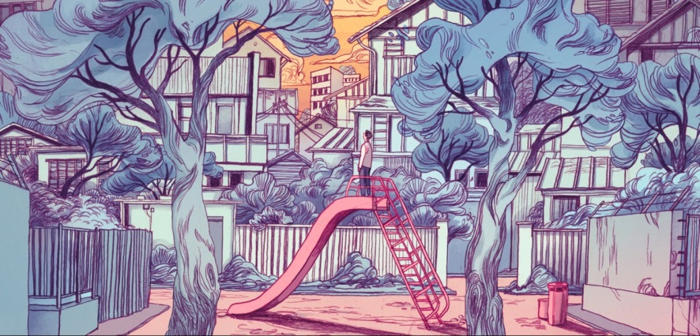
An illustration of human connection with the environment and criticism on urbanization
Artwork name: “1Q84’’
Digital illustration by: Thomke Mayer Artwork in 2018

To begin with, the composition of this illustration is greatly done to bring the attention the viewer to the main focus. The main focus of this illustration is the person standing on the playground slide. This person is placed at the center of the illustration and surrounded by the other visual elements of this illustration. Placing the person on this central position directs the focus of the viewer towards him and the activity he is carrying out. The man in this illustration is surrounded by buildings trees and fences. This also creates a sympathetic mood towards this person. The person is shown as being enclosed in a small confinement and lacks the freedom to explore his environment freely.
The artist has as well exploited several elements of design to effectively express the message in this illustration. Some of the most important aspects that the artist utilizes in this work include colors, size, shape as well as line. For instance, the size and shape element have been combined in the image of the human being to represent the person as weak and defeated. The person is represented in a small size, which shows him as an inferior character in his environment. The person appears desperate and trying to outdo the buildings surrounding him but this is all in vain. He is confined under the tall buildings that make it difficult for him to access the sky beauty or even the view of a sunset.
The person is also presented in a manner that shows that he is not fully satisfied. The way he stands on the slide clearly shows that he is not intending to enjoy the slide but looking to achieve something else. He also drops his hands and stands in a posture that indicates more of a defeat. Besides, the way the person looks up in the sky with a bent neck shows that the person desperately need to have a view of the sky.
The probable reason for the person going up on top of the playground slide is because he could not have accessed the view of the sky from the ground for he is blocked by the tall buildings above him. The artist also shows a very small part of the sky that is visible. That means that despite his efforts to try to reach to the environment, he can still not have an adequate access to it. That also explains his struggle shown in this illustration.
The artist has also used the aspect of shapes and lines to direct our eyes to some important elements in this illustration. The eyes of the viewers are attracted to familiar shapes and lines and drive their focus towards certain areas of the artwork. In this illustration, the triangular shape of the slide perfectly draws the attention of the viewer to the top of it, where a person stands. The lines of the stairways towards the top of the slide also drive the focus of the viewer toward s the person on top of the slide.
The illustration also utilizes the use of shapes that provide more details on the composition of the image. For instance, the artist dominantly uses rectangular shapes to define some of the most important elements in this illustration. The shapes define such things as the compound, the fences, the buildings and the entryway to the compound. The lines of the electric cables drive the attention of the viewers to the sky, which is an integral part of this illustration’s composition and the message.
The design aspect of color is also dominantly utilized in this illustration. The grey color is dominant in this illustration. Psychologically, it is associated with dull moods and unsettling feelings. This is shown in the posture of the man which represents his unsettled mind. This color means loss and may also indicate depression. The man in this illustration is depicted as a person who has lost the beauty of nature to urbanization. All the natural features such as vegetation have been occupied by buildings. The color also shows that the atmosphere is dirty and has no fresh air. This is a common problem in modern urban dwellings.
The reddish orange color of the ground also depicts the lack of vegetation on the ground. This color is also used predictably to shoe that the ground is turning red, as an indication of impending danger; the danger of lack of vegetation on the ground, which is environmental degradation. The golden color on the sky means indicates time. This color shows that the action on the illustration takes place during an evening sunset. The golden color is also used symbolically to show the great value of nature to human being. The person on the illustration is shown desperately seeking to get in touch with this great value.
In conclusion, while Thomke Mayer Artwork in this illustration represents a great work and shows the value of environment and nature to human being, the work seems to be a criticism on the idea of urbanization and its negative impacts not only to the nature but also to human beings. The artist utilizes the juxtaposition of dirty environment and dry grounds to represent the metaphor of the negative impacts of urbanization. The use of a human being clinging unto the sky shows how the urban population misses the opportunity to enjoy free gifts of nature such as sunlight, breezes, fresh air as well as general beauty of natural environment.

Visual Description
The artwork is a digital illustration by Thomke Mayer (2018) from Haruki Murakami’s 1Q84. It is a horizontal composition of about 2:1 length-to-width ratio which describes a Japanese neighborhood with a man standing on a child’s slide. The is about a half the height of the child’s slide and he is standing from the side, on top of the slide, facing left, and with his chin raised. He is wearing black pants and a white shirt and seems to be looking at the sky.
The child’s slide whose color is a pale shade of magenta is situated in between the two trees in such a way that it forms an equilateral triangle with a similarly colored ground. Its height is about a half that of the width of the artwork. The ladder of the child slide is situated on the right side while the slide is on the left.
The immediate background of the dominant elements in the illustrations is filled with grey-brown bungalows which are covered by perimeter walls of about the same height as that of the man in the artwork.
The dominant elements in the illustration include two grey-blue trees that are situated about a third of the distance from the sides of the illustration and, as a result, seem to subdivide the image into three equal parts. The trees have an approximately similar height with that of the illustration and are drawn using wavy, flowing, blend of thin and thick lines. The major branches of the two trees start at about two-thirds of their height and their crown is drawn in such a way that they resemble the clouds, albeit with a defined outline. Besides one of the trees; the right one, are two magenta-colored tanks standing side by side. One is about a sixth the width/height of the picture while the other, which is closer to the tree, is about a half of that. They are both standing on a ground of similar color.
The walls and the buildings are drawn predominantly using thick, straight lines. Cloud-like, grey-blue, crowns of the trees that are hidden behind the walls show up above them. The crowns are drawn with a wavy, flowing, blend of thin and slightly thick lines. The slightly cloudy sky illustrated using an orange-brown color is only observed in the top-middle part of the artwork. The artwork is predominantly wavy with thick lines defining the boundaries of almost everything. The change in colors is also not smooth and, therefore, concepts don’t smoothly merge. On this regard, it seems assertive. Additionally, the illustration appears to depict a gloomy scenario with the predominant use of non-vibrant colors such as grey-blue, orange-brown, and pale magenta in coloring the objects presented.

